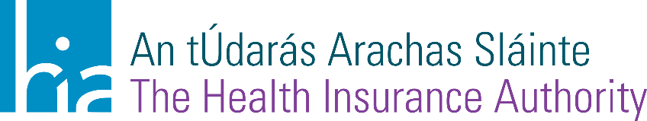

Consumers to receive savings with decrease in health insurance stamp duty for 2024

In a report published today (Friday, 8 December), the Health Insurance Authority (HIA) has confirmed a reduction in stamp duty for all health insurance policies. After a number of health insurance price increases in 2023, the HIA’s view is that the health insurance companies should incorporate the reduction in stamp duty into their pricing so that consumers can feel the full benefit. The recommendation to reduce the stamp duty is based on recent trends in the health insurance industry as well as consultation with the health insurance companies. The annual stamp duty supports the community rating system which allows everyone, regardless of their health status and other risk factors, to buy the same health insurance policy at the same price.
Advising policy holders who are due to renew their policy soon, Ray Dolan, CEO of the HIA, said:
“The reduction in stamp duty is something that we hope will provide a small saving to consumers. We estimate that at this particular time of year, over 50% of people are renewing their health insurance, and we would hope that consumers see this saving in their renewal premium. Of course, we would always encourage people to review their existing policy and see is it meeting your health needs. You can compare all plans on hia.ie.”
The reductions vary, but most (72%) consumers will see an €18 reduction in stamp duty for their advanced policies, which are policies that generally provide cover for both public and private hospitals. Advanced policies are held by 93% of people with private health insurance.
For more information about the HIA and the private health insurance market, visit www.hia.ie. The HIA encourage all health insurance consumers to review their policies before they renew, and to use the HIA’s comparison tool (https://www.hia.ie/health-insurance-comparison) to compare policies and to find ways to save. Consumers can also call the HIA’s free helpline (01 406 0080) to discuss health insurance and get more information from a consumer adviser. The full report is available at https://www.hia.ie/regulations/risk-equalisation.

ENDS

For more information contact:
Marie Lynch, Account Director, Carr Communications, marie@carrcommunications.ie, 087 973 0522 or Éabha Griffin Kelly, Account Executive Carr Communications, egriffinkelly@carrcommunications.ie, 087 671 6394.

Notes to the editor
For more information health insurance policies and finding the policy most suitable for your needs, visit www.hia.ie to use our free comparison tool.

About the Health Insurance Authority (HIA)
The role of the HIA is to ensure consumers are aware of their rights and insurers know their responsibilities in relation to health insurance in Ireland. The HIA enables a functioning health insurance market for the benefit of consumers, providers and policy makers that underpins an accessible health service.

The HIA is responsible for effectively monitoring the compliance of registered undertakings with the Health Insurance Acts and accompanying regulations and taking measures to secure such compliance.

The Health Insurance Act 2013 provides the legislative basis for the Risk Equalisation Scheme and the Risk Equalisation Fund, the mechanisms used to implement and support Lifetime Community Rating in the Irish health insurance market.

For more information and to access the comparison tool visit: www.hia.ie

